Designating WIOA Co-Enrollment in TE
On the Records menu, go to Students and select Records.

- Click the New button in the upper left corner of the lister.
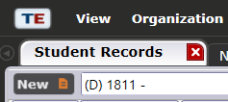

- Find the field title Personal Status Entries and select the appropriate WIOA program.
  - WIOA, Title I
  - WIOA, Title III
  - WIOA, Title IV
