**ELL Co-Enrollment Pilot Project**

**Frequently Asked Questions: Data Protocols**

This FAQ supports ELL Co-Enrollment Pilot Project data entry protocols. More detailed training and reference materials can be found in the resources identified below:

* ELL Co-Enrollment data training webinar including [overall guidance inclusive of specific guidance for TOPSpro](https://edd.connectsolutions.com/p1310iq08gw/?proto=true) and [CalJOBs](https://edd.connectsolutions.com/p775jzcf2l2/?proto=true)
* [Using the EL Co-Enrollment Designation in CalJOBs](https://calworkforce.org/wp-content/uploads/2019/12/3-TE-areas.pdf)
* [Using the ELCOE Designation in TE](https://calworkforce.org/wp-content/uploads/2020/03/Using-the-ELCOE-Designation-in-TE.pdf)
* [Designating Title 1-III-IV in TE](https://calworkforce.org/wp-content/uploads/2020/03/Designating-Title-I-III-IV-CoEnrollment-in-TE.pdf)
* [Adding CalJOBS ID for an Existing Student in TE](https://calworkforce.org/wp-content/uploads/2020/03/CalJOBS-ID.pdf)

1. **What counts as co-enrollment for purpose of the grant?**

Co-enrollment may include enrollment in Title I, Title II/Adult Education Programs, Title III, Title IV and Human Service Programs or other WIOA Unified Plan Programs (see California’s [current state plan](https://cwdb.ca.gov/plans_policies/) for additional information). Human Service Programs can include CalWORKS, CalFresh, CalFresh Employment & Training, Refugee Programs, and other programs under the health and human services umbrella. Additional information on California’s draft guidance on co-enrollment in WIOA can be found [here](https://www.edd.ca.gov/Jobs_and_Training/pubs/wsdd-199.pdf). A list of California’s WIOA Plan partners can be accessed through a link accessible at the bottom of this information notice on [Statewide WIOA Co-Enrollment Guidance.](https://www.edd.ca.gov/Jobs_and_Training/pubs/wsd19-09.pdf)

1. **How is co-enrollment data captured for this grant?**

Co-enrollment data is captured in several ways for the purposes of this grant:

* Co-enrollment between Title I and Title II services are captured by inputting the CalJOBS ID into TOPSpro Enterprise (TE) to allow for validation of co-enrollment and services provided between CalJOBS and TE. It is also necessary to identify the individual as a participant in the ELL Co-Enrollment Pilot Project using the appropriate designation in the drop-down menu. A tip sheet on how to do this can be found [here.](https://calworkforce.org/wp-content/uploads/2019/12/3-TE-areas.pdf) Staff should also ensure they record Activity Code 222 (ESL) and/or Activity Code 214 (Adult Literacy, Basic Skills and GED), in CalJOBs to reflect these services as appropriate.
* Co-enrollment between Title I and Title III is captured by enrolling individuals in the appropriate program(s) in CalJOBS; staff should also ensure they record Activity Code 108 (Title III Wagner Peyser) in CalJOBS to reflect these services.
* There is currently no comprehensive data interface between CalWORKS, CalFresh, CalFresh Employment & Training, or Refugee Programs so it is important that grantee sites both note this co-enrollment in their internal data tracking systems and use Activity Code 140 (Health and Human Services) in CalJOBS to reflect this co-enrollment and services provided.

In all cases, it is recommended as a best practice that sites track co-enrollment in their internal tracking systems as well to support ongoing data validation efforts as a part of performance management and evaluation activities.

1. **How does co-enrollment in this grant relate to co-enrollment in the context of Integrated English Literacy and Civics Education (IELCE)?**

Co-enrollment for this grant is defined differently than co-enrollment in the context of IELCE. Please refer to the definition of co-enrollment provided in *Question 1* for guidance on what counts as co-enrollment in this grant. The image below also compares the ELCOE co-enrollment with that of IET. Guidance on using the ELCEO designation in TE can be found [here](https://calworkforce.org/wp-content/uploads/2020/03/Using-the-ELCOE-Designation-in-TE.pdf).

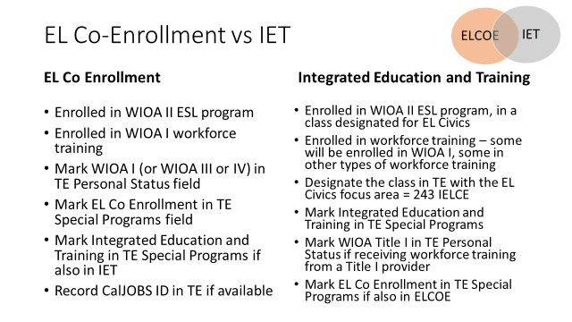

1. **How does one capture information about a participant’s native language and language preference?**

Language preference is captured in the individual’s CalJOBS registration, not in the WIOA application. To access this question, when assisting an individual, staff should access the “General Information” section of the Personal Profile.

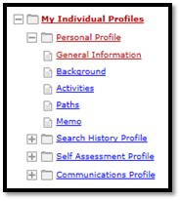

In the Ethnic Origin section, if the individual selects “yes” to the first language question, subsequent questions appear including the Primary Language.

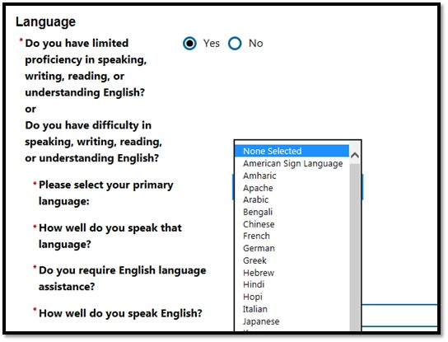

1. **What should we do if CalJOBS does not have activity codes for specific outcomes that our project has identified?**

Please reach out to Kae Chin ([kae.chin@edd.ca.gov](mailto:kae.chin@edd.ca.gov)), the EDD project manager, identifying the specific outcome(s) that you are seeking an activity code for. Please include the following individuals on copy:

Amber Shevin, [amber.shevin@rescue.org](mailto:amber.shevin@rescue.org)

Renatta DeFever, [Renatta_DeFever@spra.com](mailto:Renatta_DeFever@spra.com)

Ursula Bischoff, [umbischoff@gmail.com](mailto:umbischoff@gmail.com)

It is also helpful to track this information in your internal tracking sheets to support high-quality data capture and grant performance reporting.

1. **We have ELLs that are co-enrolled but they are not being served directly by this funding stream. How should we record data for these participants?**

It is fine for your team to record co-enrollment through the general guidance for capturing this type of co-enrollment in TOPSpro and CalJOBS – namely, using the correct activity codes to note this co-enrollment in these systems. Grantees should only enter the specific CalJOBS and TopsPRO ELL Co-Enrollment Pilot Project grant codes for participants that are directly enrolled in this grant program which means that they are being served by staff that are funded through this grant and that they are participating in the program model and services that your grantee team proposed in your application.

**Example:** Your program model includes partnership with three local adult schools and your project team is collaborating to build out vocational ESL classes in healthcare and construction and then connecting these people to training programs and career counseling through the AJCC to help them earn credentials and get jobs.

*Scenario 1:* An ELL comes into the AJCC seeking to apply for training funds for a software training program at a local university. He mentions he has taken some ESL classes at a local adult school in the past year. For this person it would be appropriate to:

* Use the appropriate codes in CalJOBS to record participation in these ESL classes (Activity Code 222)
* Share the CalJOBS ID with the ESL school he mentioned if you have a good point of contact
* Not record the ELL Co-Enrollment Pilot Project code for this person

*Scenario 2:* An ELL comes into the AJCC seeking help finding a job. She mentions that she has started to take some ESL classes at the local adult school. You refer her over to the ELL Navigator where she learns about a special program you have developed in partnership with the local adult school that includes vocational ESL classes for the healthcare industry and then share with her that through the AJCC you can help her access training funds for a medical assistant class and that you can also help her find a job.

* Record the ELL Co-Enrollment Pilot Project code for this person
* Use the appropriate codes in CalJOBS to record participation in these ESL classes (Activity Code 222)
* Share the CalJOBS ID with the ESL school she mentioned if you have a good point of contact; if you do not, work with your local adult education consortia to identify a good point of contact
* Ensure that the adult school point of contact enters the CALJOBS ID in TopsPRO and selects the ELL Co-Enrollment Pilot Project in TopsPRO as well
* Note this co-enrollment in your internal tracking system

1. **We have ELLs that we are thinking about enrolling in this project and we have learned that they are already co-enrolled with services and partners that qualify as co-enrollment under Question #1 but they are not participating in the program model and services that we proposed in our application. How should we record data for these participants?**

It is fine for your team to record co-enrollment through the general guidance for capturing this type of co-enrollment in TOPSpro and CalJOBS – namely, using the correct activity codes to note this co-enrollment in these systems. Grantees should only enter the specific CalJOBS and TopsPRO ELL Co-Enrollment Pilot Project grant codes for participants that are directly enrolled in this grant program which means that they are being served by staff that are funded through this grant and that they are participating in the program model and services that your grantee team proposed in our application.

**Example:** Your program model includes having the ELL Navigator offer orientations at local adult school ESL classes to help people learn about a construction apprenticeship program that includes specialized support for Spanish speakers as well as the opportunity to participate in job readiness classes and career counseling through the AJCC.

*Scenario 1:* The ELL Navigator is visiting the construction apprenticeship program and in chatting with one of the apprentices, learns that he is also receiving services through a local refugee-serving organization. In this case, it would be appropriate to:

* Not record the ELL Co-Enrollment Pilot Project code for this person
* If at a later point, he came to the AJCC to access services, you would use the appropriate codes in CalJOBS to record participation in these health and human service programs (Activity Code 140) only

*Scenario 2:* The ELL Navigator is six months into the project and thinking about additional partners that might help strengthen the program since the team is having difficulty reaching the target population through their current outreach strategies. She works on building a partnership with a local refugee serving organization and begins to provide orientations on the construction apprenticeship program in their community-based work readiness classes. Through this work, she identifies six individuals that she supports in enrolling in the construction apprenticeship program and welcomes them into job readiness classes and career counseling through the AJCC. The refugee-serving organization continues to provide case management support to these individuals and the ELL Navigator and the refugee case manager meet monthly to ensure coordinated support for these participants. In this case it would be appropriate to:

* Record the ELL Co-Enrollment Pilot Project code for this person
* Use the appropriate codes in CalJOBS to record participation in these refugee services (Activity Code 140)
* Note the co-enrollment in your internal tracking system

1. **Who should I reach out to if I have questions about recording data for participants in the ELL Co-Enrollment Project?**

Please reach out to Kae Chin ([kae.chin@edd.ca.gov](mailto:kae.chin@edd.ca.gov)), the EDD project manager, with the following individuals on copy:

Amber Shevin, [amber.shevin@rescue.org](mailto:amber.shevin@rescue.org)

Renatta DeFever, [Renatta_DeFever@spra.com](mailto:Renatta_DeFever@spra.com)

Ursula Bischoff, [umbischoff@gmail.com](mailto:umbischoff@gmail.com)