Locating a State ID in CalJOBS:

- Log into CalJOBS. Once logged in, open up the tab “Services for Workforce Staff”:
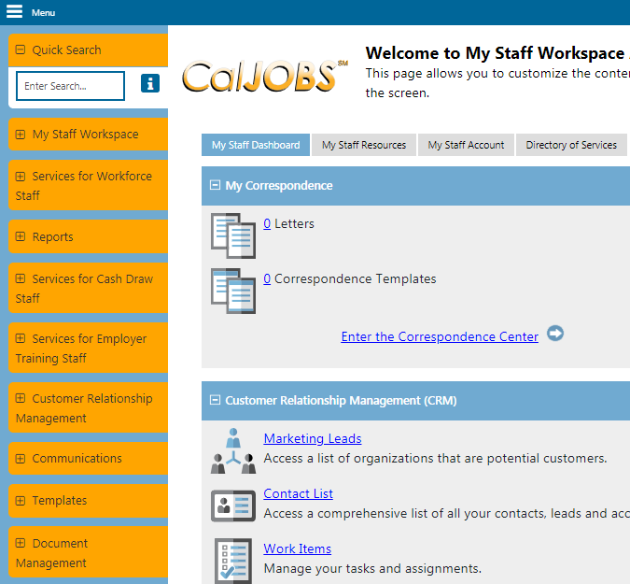

- From there, hover over the “Manage Individuals” section to expand more options and then click on “Assist an Individual”:

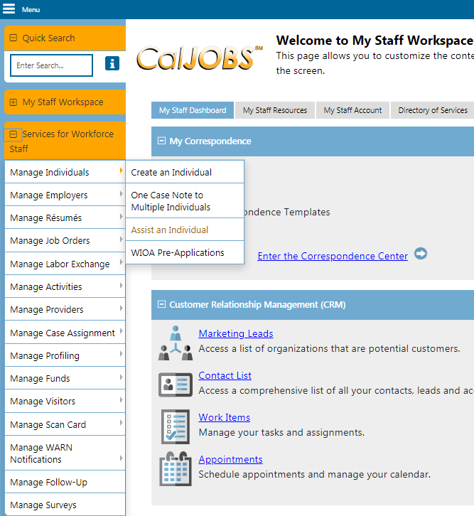
- Once the screen has loaded, scroll down to the “General Criteria” section and you search for an individual using their State ID number:

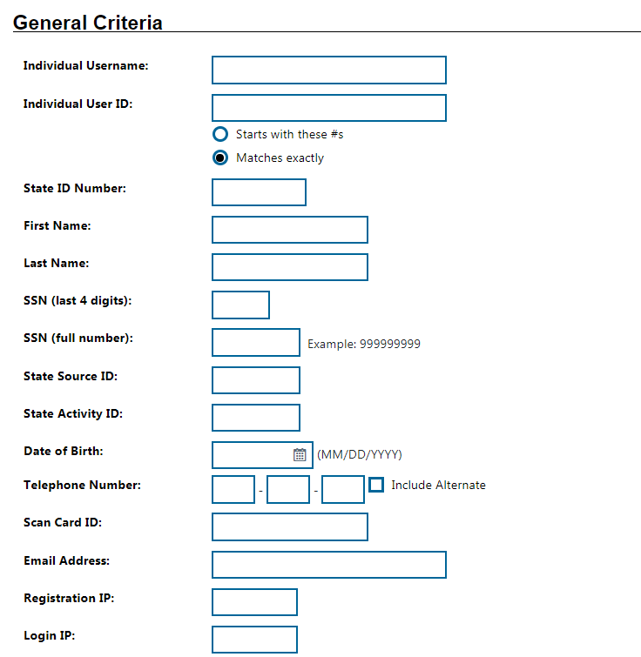

- If you don’t have the individual’s State ID number and are trying to find that information, you can type in either their User ID number, Username, SSN etc. Use any of the available information in the “General Criteria” section and then click on “Search” located at the bottom of the page:
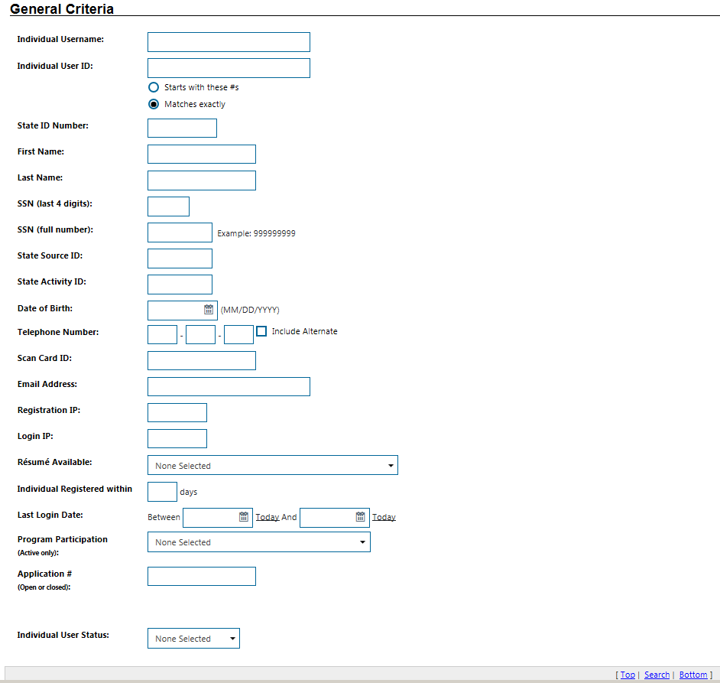
- If you’re trying to locate an individual’s State ID number on their profile, that should load when you search for an individual is the “Case Summary” page and you will see a bunch of folders at the top of the page along with hyperlinks to other parts of the individual’s profile that you could click on and go to:
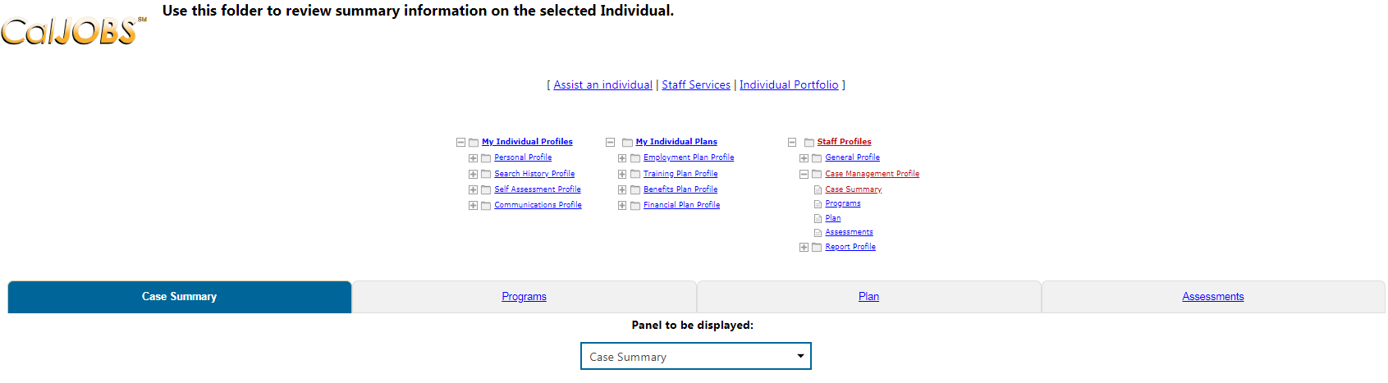
Right below the folders is the “Individual Information Panel” and that’s where you can locate the State ID number on the right-hand side:

So the overall path to locating a State ID number on CalJOBS should go:
Log into CalJOBS > Go to Manage Individuals > Click on Assist an Individual > Type in the individual’s info in the General Criteria page > Click on Search > Individual’s Summary page should then appear
Additional Information:
- State IDs cannot be edited or changed. They are system generated by CalJOBS.
- You can use any of the available search information to find an individual but I would recommend using the individual’s User ID, or Application # in order to remove multiple individuals show up in your search.
- Before an individual’s summary page appears, a “Right to Work Verification” page may appear beforehand:
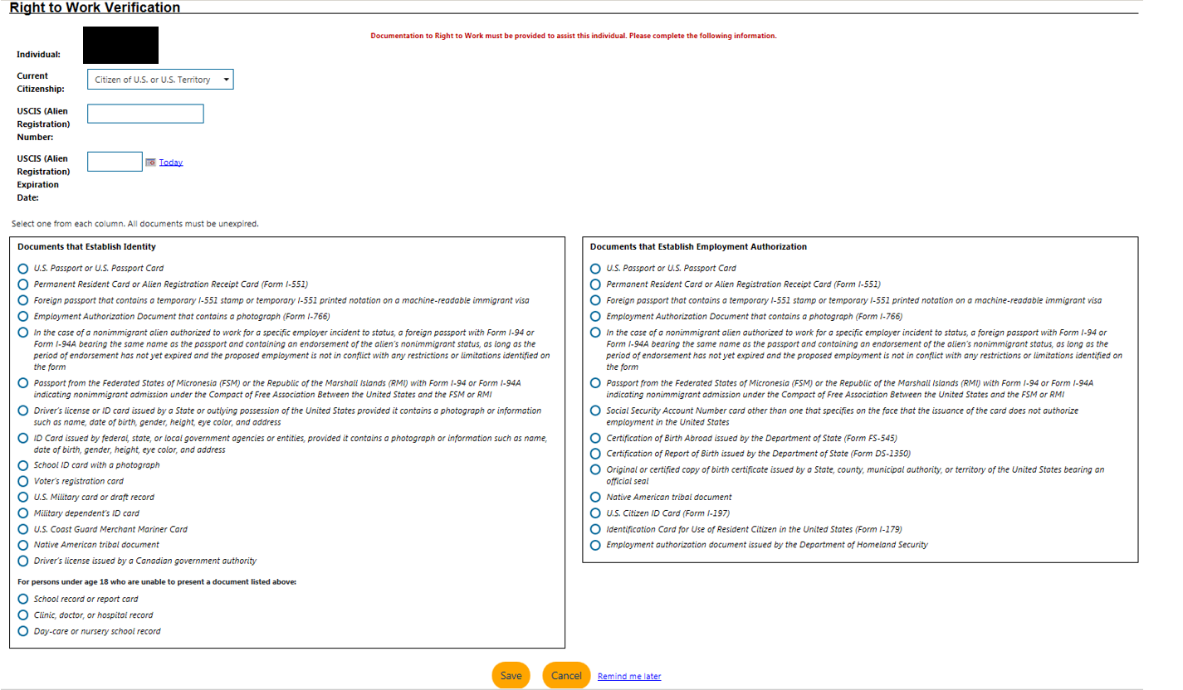

Just click on “Remind me later” to move on and continue viewing the individual’s information. Do not click on “Save” or “Cancel” as canceling will kick you out of the search and saving will have CalJOBS asking you to fill out all of the info on this page. Just click on “Remind me later” to proceed.

