Using the EL Co-Enrollment Designation in TE
For designating individual students:
- On the Records menu, go to Students and select Records to open the Records – Students – Records lister.

- Click the New button in the upper left corner of the lister.
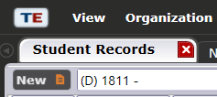

- Check the box titled EL Navigator under Special Program Entries
For designating an entire class:
- On the Organization menu, go to Classes and select Instances.

- Click the New button in the upper left corner of the Class Instance record.

- Check the box titled EL Navigator under Special Program Entries

