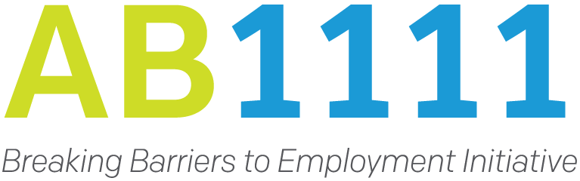
Breaking Barriers to Employment Initiative
Summer 2021 Community of Practice
Strategies for Success!
June 22nd and 23rd, 2021
9:30 AM – 12:00 PM (both days)

AGENDA
How to Access Sessions:
- Step 1: If you haven’t already done so, you can click the following to Get Registered!
- Step 2: Once registered, you can access the session from the following Zoom Link. Same link for all sessions.

Technical Support: Technical support (both on and offline) will be provided by California Workforce Association (CWA). Feel free to reach out to Xue Lor and Brandon Anderson via email (xlor@calworkforce.org and banderson@calworkforce.org) or contact your hosts in the Zoom chat.

Day 1: June 22, 2021 9:30 AM – 12:00 PM
9:30-9:50 | Welcome and Opening Remarks  Welcome to the AB1111 Breaking Barriers to Employment Initiative Summer 2021 Community of Practice Convening! Please join us at the top of the program for a welcome message and opening remarks by:  Tim Rainey & Bob Lanter  Executive Directors,  California Workforce Development Board and  California Workforce Association  Overview of Community of Practice | Brandon Anderson,  California Workforce Association  Amanda Gerrie,  Pathways Consultants
9:55-10:30 | Economic Recovery and America’s Jobs Plan Panel Discussion  CWA’s Bob Lanter, Executive Director, will facilitate a panel discussion featuring Chris Andresen of Dutko Government Relations and CWA’s Federal Lobbyist, and Stephen Lynch of Burning Glass Technology, VP, Workforce & Economic Development Solutions. This panel will feature a discussion on the American Jobs Plan and what the data tells us about the upcoming economic recovery and implications for California job seekers, particularly those significantly impacted by the COVID-19 pandemic. | Facilitated by Bob Lanter Executive Director,  California Workforce Association
10:30-10:35 | Stretch Break
10:35-11:55 | Increasing Job Placement and Business Outreach in a Challenging Labor Market  The past fifteen months have wreaked havoc on programs that need to make placements. In essence, the economy shut down. This downturn has been different than prior recessions because employment has been impacted on both the demand side and the supply side. Employers needed fewer workers as businesses shrunk in size or closed. At the same time, many workers left the labor market over health concerns, childcare, homeschooling, and government policies. Now that businesses are reopening, programs need practical short-term and long-term strategies that can quickly get participants into jobs and help employers find workers. This session will focus on practical strategies that will help programs quickly improve placement rates while best meeting the needs of local employers, the agency partners, and the work-ready participants. | Jodie Sue Kelly,  Cygnet Associates
11:55-12:00 | Takeaways & Wrap-up | Pathways Consultants & CWA
12:00-12:45 | Optional: Lunch Time Networking with Room Topics-World Café Style | Pathways Consultants & CWA

Agenda Day 2: June 23, 2021 9:30 AM – 12:00 PM
9:30-9:40 | Welcome & Overview of the Day | CWA & Pathways Consultants
9:40-11:00 | Navigating The Impact of Trauma & Vicarious Trauma  In this workshop, we will learn more about the impact of trauma on individuals and the effect it may have on one's ability to engage and thrive in employment services. We will also learn about the impact of vicarious trauma, compassion fatigue, burn-out and moral distress on one's ability to effectively provide services. This workshop will also discuss the impact COVID has had on all and more specifically how that has shown up in the workplace. Strategies for engagement and addressing vicarious trauma will be shared. | Nola Brantley,  Nola Brantley Speaks
11:00-11:05 | Stretch Break
11:05-11:50 | AB1111 Provider Panel Discussion:  The Art of the Pivot- Successfully Responding to Challenges  Panelists:  Carma Lacy, Executive Director, Orange County Workforce Development Board  Sam Bedwell, Deputy Director, Nile Sisters Development Initiative  George Weaver, Vice President of Special Programs, Los Angeles Brotherhood Crusade | Facilitator:  Ruth Barajas,  Bay Area Community Resources
11:50-12:00 | Takeaways & Wrap-up | Pathways Consultants & CWA

Sponsored by the California Workforce Development Board
Brought to you in partnership with
California Workforce Association and
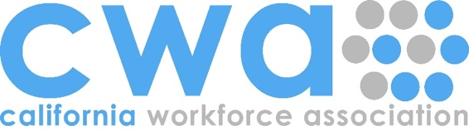
Pathways Consultants

